MEDIA KIT
John Cruthers presents
Re/production: Australian art from the 1980s and 1990s
29 August – 10 October 2020
16albermarle Project Space
16 Albermarle Street Newtown 2042

Elizabeth Newman Blank canvas 1985 oil on canvas 76.2 x 91.7 cm

MEDIA CONTACT |John Cruthers | john@16albermarle.com | +61 (0)433 020 237 |
MEDIA RELEASE
In this moment of radical change and redefinition of social structures, Re/production: Australian art from the 1980s and 1990s presents a diverse selection of works from these generative decades in recent art history. This was a time to “question the truth of perception and the very idea of authentic experience that had been central to the modern project”, in which “all those qualities beloved of modernism - originality, authenticity, artistic creativity, formally novelty and innovation – came under question”.

This first exhibition of Australian art at 16albermarle Project Space is curated by director John Cruthers and reflects his personal enthusiasm for and knowledge of this period’s art. The exhibition includes works by leading figures in the development of post-modern and post-colonial art, collected and recommended by John:

I moved from Perth to Sydney in 1977 to study at the Film and Television School. I worked mostly on social documentaries motivated by an intense belief in our capacity to change society through our work. As my political fervour grew my interest in mainstream Australian art lessened. But after graduating I was drawn to experimental short films and worked on Serious undertakings (1983, Helen Grace) and Camera natura (1984, Ross Gibson), two films which signalled the arrival of post-modernism in Australian cinema. And at Perspecta 1983, curated by Bernice Murphy at the Art Gallery of NSW, I saw a new kind of art that reflected these new ideas and developments. I became an enthusiastic viewer and collector, and in 1985 began working as an art adviser, recommending work by many of these artists.

Re/production thoughtfully creates new dialogues between artists that articulate the key ideas and tendencies that defined this time and provides a context through which issues including representation, identity, history, postcolonialism and institutional critique have evolved and expanded in Australian art. A highlight is a group of 10 works by Tim Johnson exploring the development of his practice from 1977 to 1983 and documenting his growing engagement with Aboriginal art and artists from Papunya.
The exhibition is accompanied by an online exhibition and an 82 page digital catalogue featuring an essay by Dr Catriona Moore on the period and commissioned texts by many of the exhibiting artists reflecting on their works in the exhibition and the contexts in which they were produced.
Re/production will present works by 26 artists including Howard Arkley, Angela Brennan, Ian Burn, Janet Burchill, Stephen Bush, Eliza Campbell & Judith Lodwick, Juan Davila, Anne Ferran, Tim Johnson, Tim Johnson & Clifford Possum Tjapaltjarri, David Jolly, Narelle Jubelin, Pat Larter, Vivienne Shark LeWitt, Geoff Lowe, Linda Marrinon, Elizabeth Newman, John Nixon, Susan Norrie, Luke Parker, Mark Titmarsh, Peter Tyndall, Savanhdary Vongpoothorn.
Re/production: Australian art from the 1980s and 1990s runs until 10 October 2020

ABOUT JOHN CRUTHERS:
John has thirty five years experience working with private collectors to build collections of Australian and indigenous art, for clients including Rupert Murdoch and Reg and Joy Grundy. He’s a collector himself, working with his mother Sheila Cruthers to build the Cruthers Collection of Women’s Art, which his family donated to the University of Western Australia in 2007. Numbering over 700 artworks, it is Australia’s largest stand-alone collection of women’s art. John is the chair of the public foundation Sheila: A Foundation for Women in Visual Art. Since 2013 John has focused on southeast Asian art, travelling widely in the region to visit galleries, collectors, museums, collectives and many artist’s studios. In 2019 he set up 16albermarle to showcase art from this region.

ABOUT 16albermarle Project Space:
Located in Newtown in Sydney’s inner city, 16albermarle exhibits a diverse range of art, both international and Australian, and specific projects focusing on art-related activities. Initial exhibitions will showcase contemporary art from southeast Asia made by younger artists working across a range of media. 16albermarle will also stage an annual exhibition of Australian art after 1980.
https://www.16albermarle.com/

EXHIBITION #3 KEY DATES:
Presentations and Artist talks: Tim Johnson 28 August 2020
Mark Titmarsh 4 September 2020
Exhibition opening: Saturday 29 August 2020 11am – 5pm by appointment
Exhibition dates: 29 August - 10 October 2020

LINKS:

Catalogue
https://static1.squarespace.com/static/5d566a1b3286c70001282e7a/t/5f50e97bb585b968ec0a4def/1599138223114/Re%3Aproduction+Australian+art+from+the+1980s+and+1990s+catalogue+.pdf

Online Exhibition
https://www.16albermarle.com/reproduction-artworks

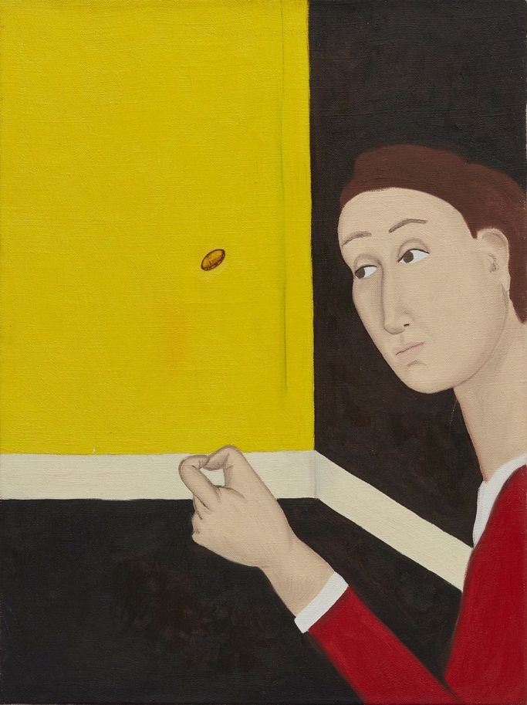
SELECTED IMAGES:
Linda Marrinon
(Tossing a coin) c 1985
oil on canvas
61 x 45.5 cm

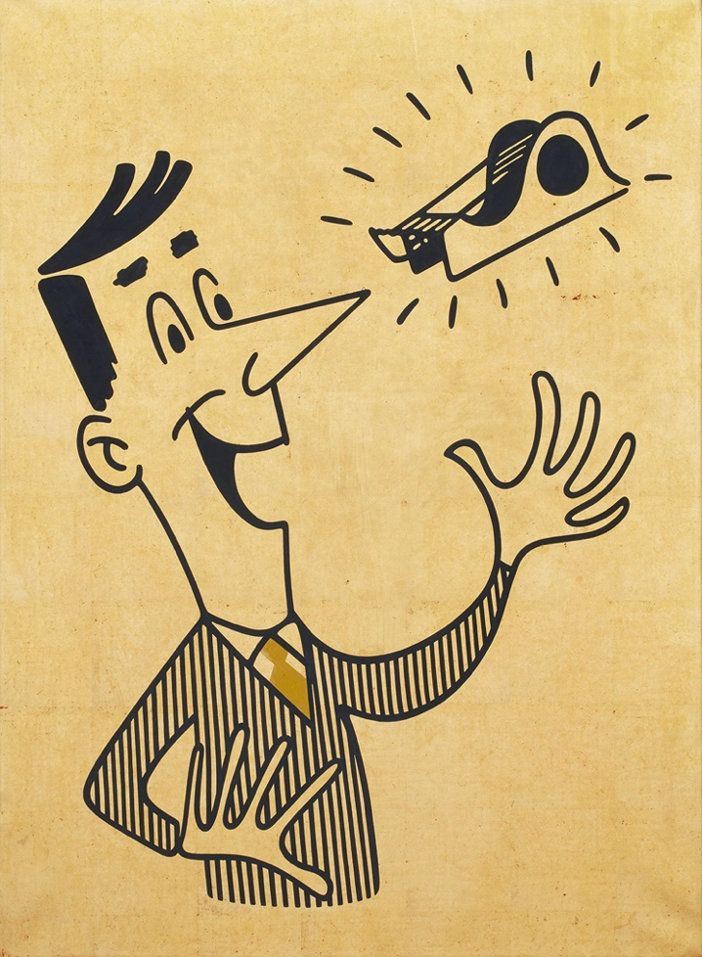
Peter Tyndall
detail: A Person Looks at a Work of Art / someone looks at something... 1985
acrylic & oil on canvas with gold leaf
78. 5 x 55.5 cm

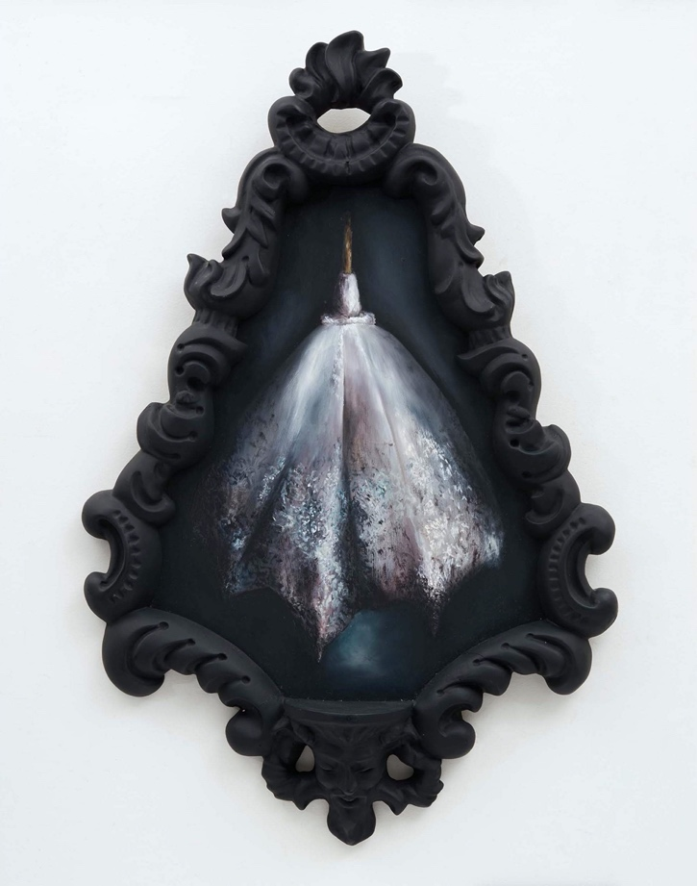

Susan Norrie
Untitled (from Determined) 1985
oil on plywood
45 x 35 cm (painting
66.5 x 45.5 cm (frame)

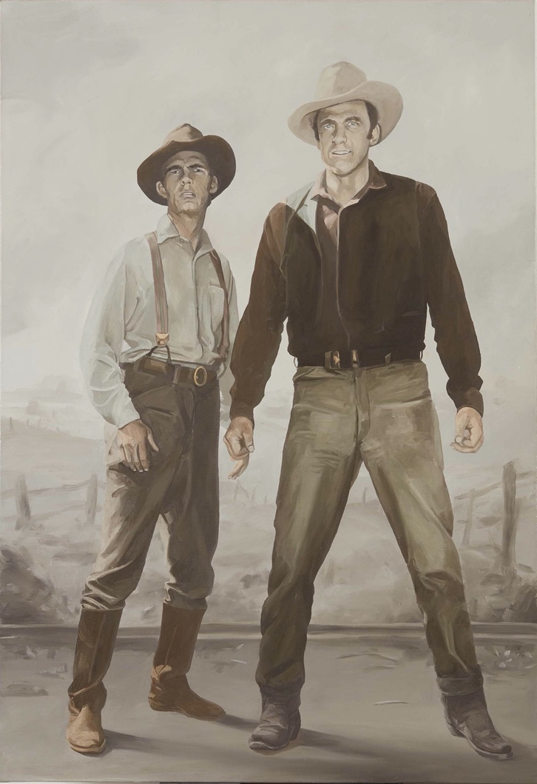
Stephen Bush
Cow hands 1988
oil on canvas
137 x 62 cm

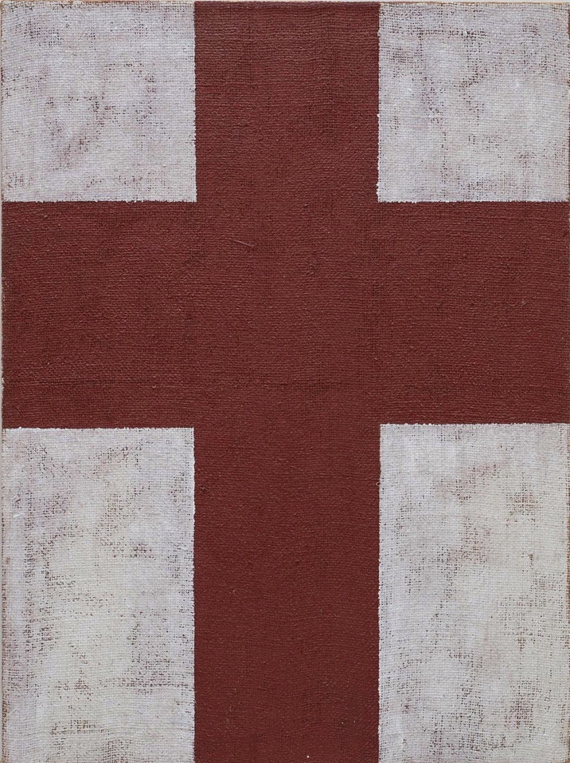
John Nixon,
Untitled 1984
oil on hessian
101.5 x 76 cm

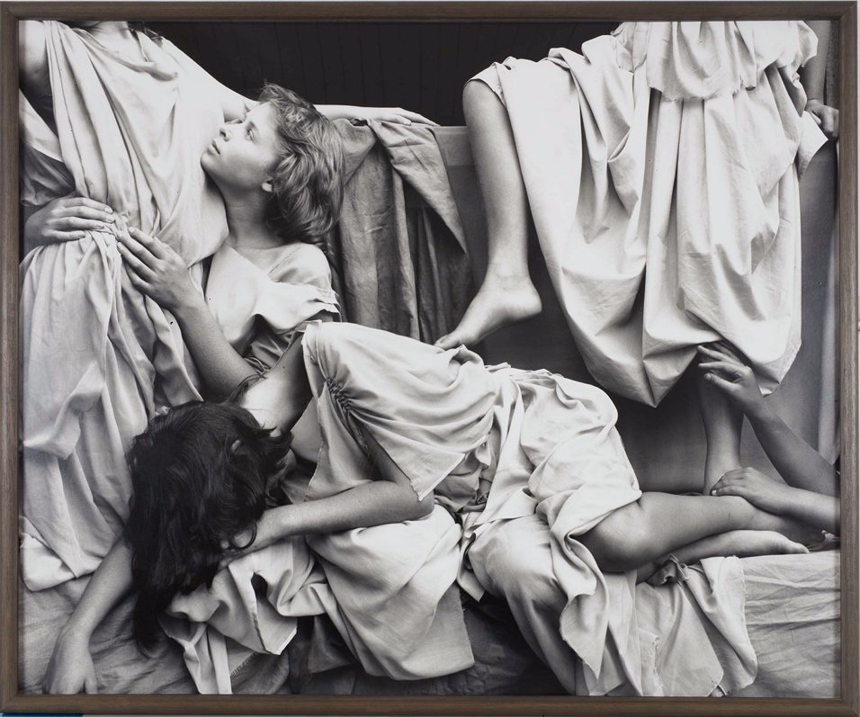
Anne Ferran
Scenes of the death of nature II 1986
silver gelatin photograph
121 x 146 cm

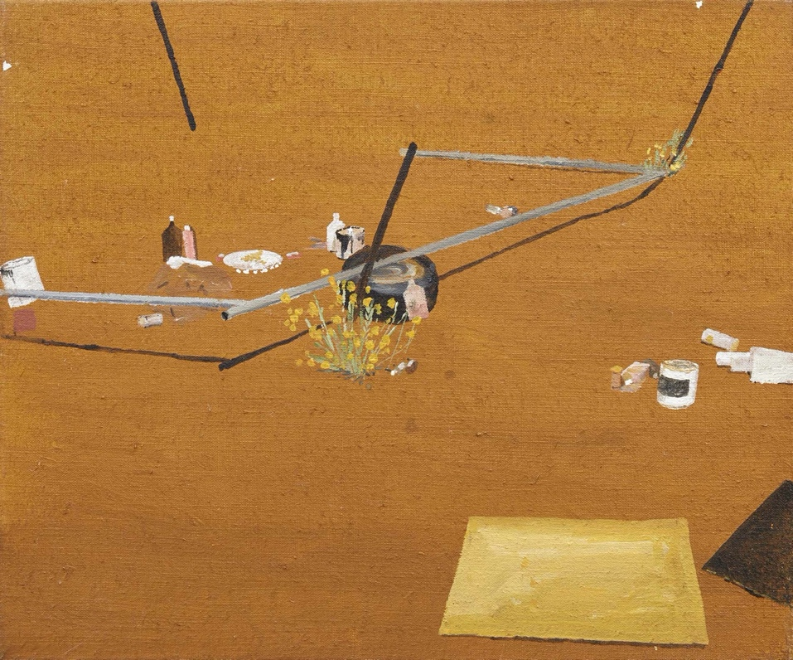
Tim Johnson
Clifford Possum's studio 1982
acrylic on canvas
37.7 x 45.5 cm

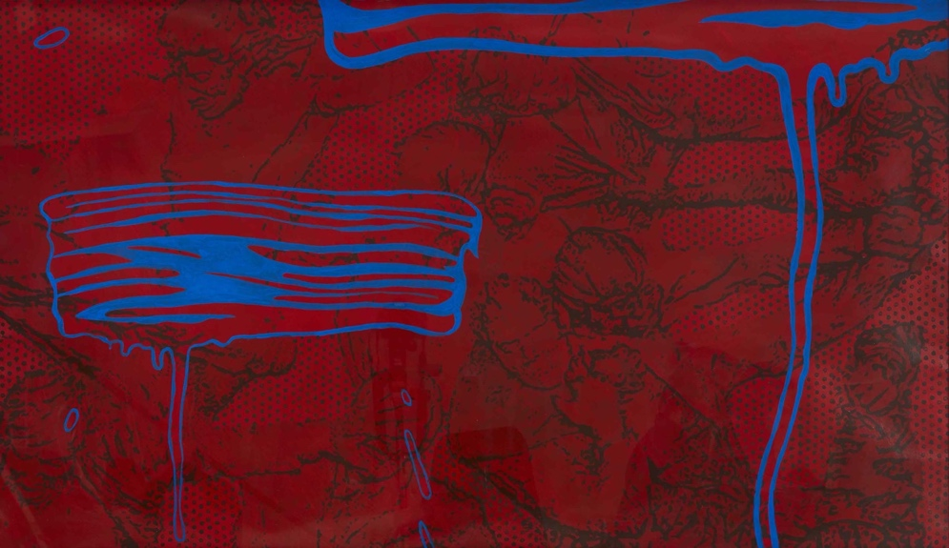
Mark Titmarsh
Advanced DefJam 1987
acrylic on paper
100 x 180 cm

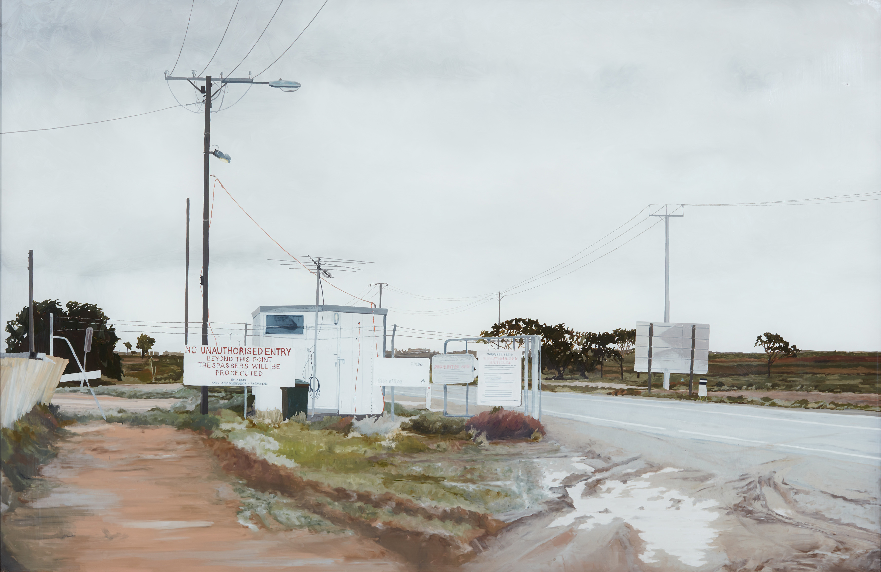
David Jolly
Gatehouse 2002 (from Woomera series)
oil on glass, 43 x 66 cm

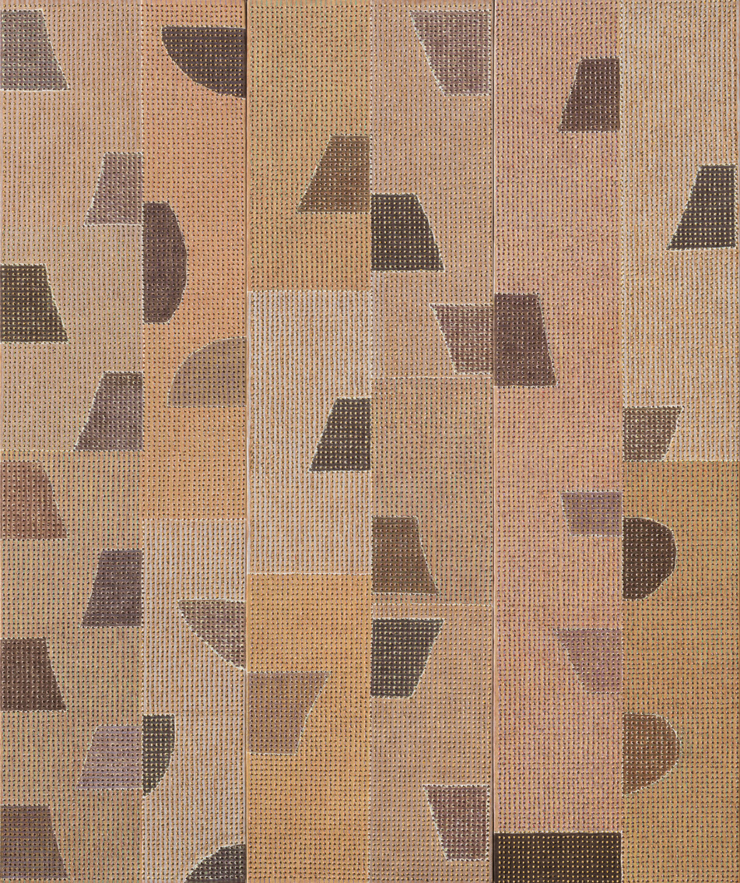
Savanhdary Vongpoothorn
Either side 2002
acrylic on perforated canvas, 180 x 150 cm

For high resolution images please contact
Emily Taylor gallerymanager@16albermarle.com

Catriona Moore Bananarama Republic

